APPLICATION DOCUMENT
eLoc Search (Portal)

Application : eLoc Search

Prerequisites :
- PHP 5.7 or above
- WAMP
- Text Editor
- Browser (Latest Version)
LOGIN (Flow Chart) :

Start
MMI Portal
Upload CSV
Insert eLOC separated by ; or ,
Search or
Insert/Update

Manually
or CSV
Upload CSV
Upload CSV
Insert or Update

Index Page

DASHBOARD :- Common page for all users. Following Links are present :

NOTE : Admin button works differently for different users.

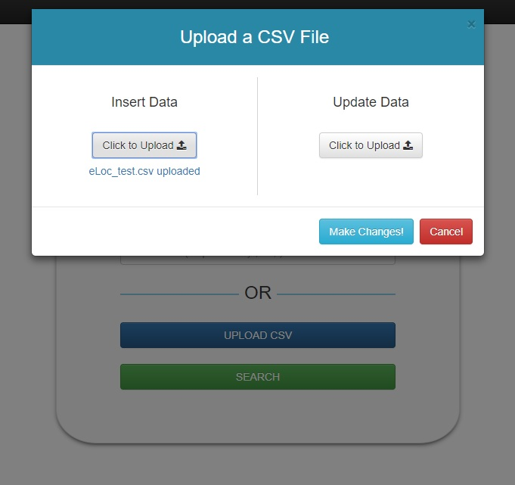
- Admin Button:- Opens modal for an admin and redirects others to login page.

1A. For Admin Users

- Insert Data :- This option is to insert the data in the database using a CSV file. The CSV file must have equal number of columns as required (10 columns). On uploading a file, a small notification area tells the user about the name of the file selected.

- Update Data : This option is to update the data already present in the database using a CSV file. The CSV file must have equal number of columns as required (10 columns). The program looks for the eLoc value in the file and updates the corresponding values for this eLoc. On uploading a file, a small notification area tells the user about the name of the file selected.

On performing any of these two operations, a message is given to the user regarding the changes made or errors found during the function.
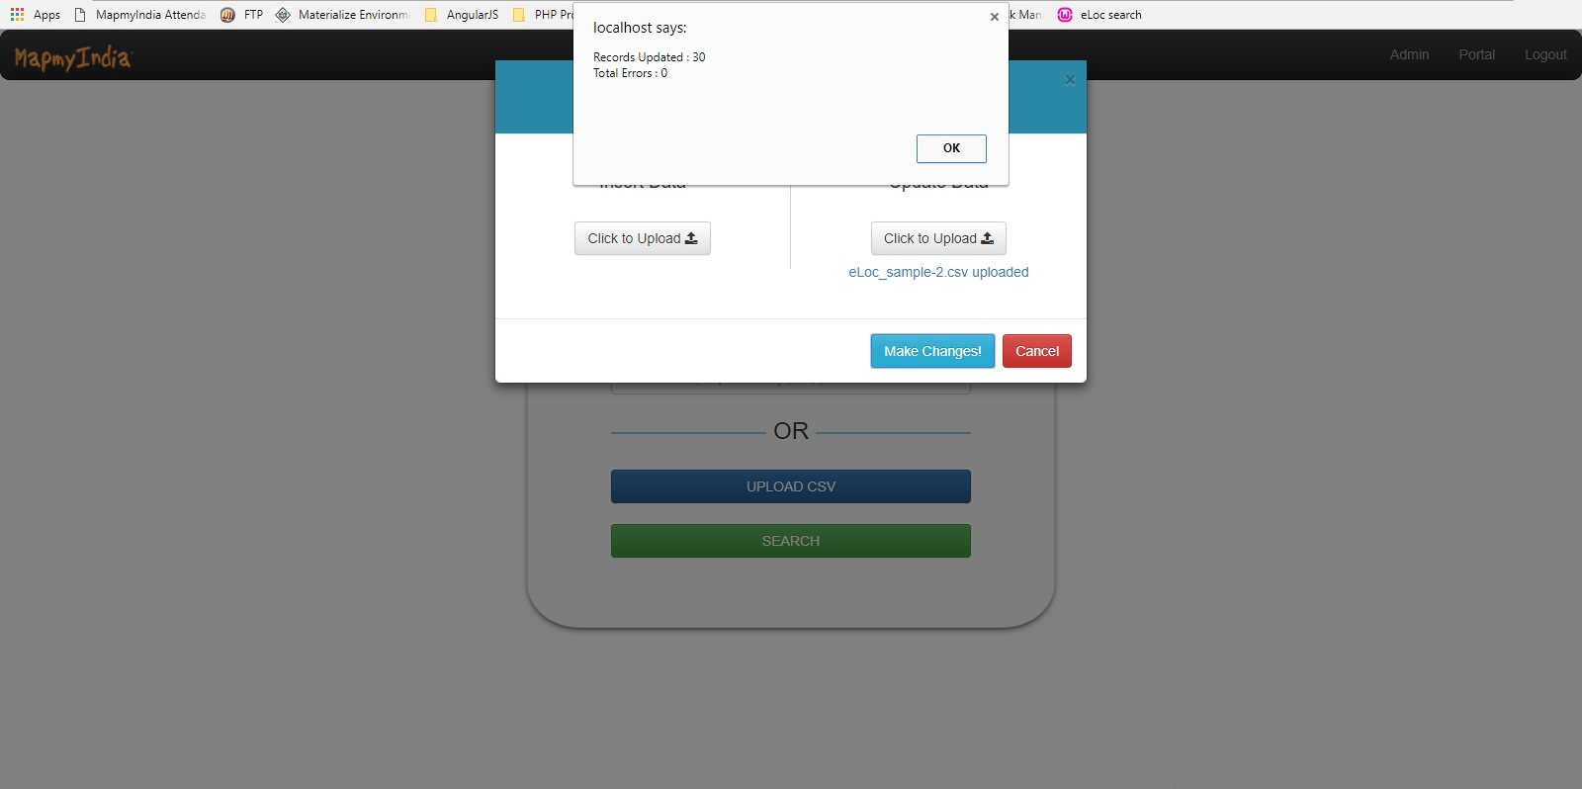
2A. For Other Users
Users, other than the admin users, are redirected to the login page.
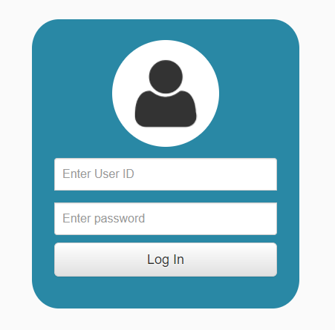

- Portal Link :- This link will redirect the user to the Portal Page.



- Logout :- This link will logout the user and redirect the user to the Portal Page.

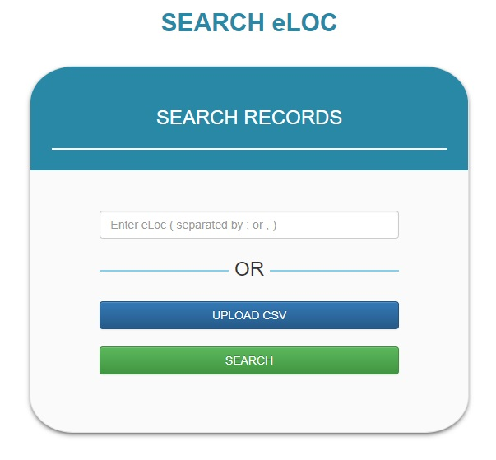
- eLoc Search Form :-

Following fields are present in the form :-
- Enter eLoc Textbox : Enter eLoc values to be searched for. Separate these values, if multiple, using semicolon ( ; ) or comma ( , ).
- Upload CSV Button : Upload a CSV file to search for eLoc values present in either the first column or the second column of the file where first column may be used to represent the serial numbers.
On clicking the Search button, this form slides towards the left of the screen and the results are shown on the right side if present or No Records found message is given.
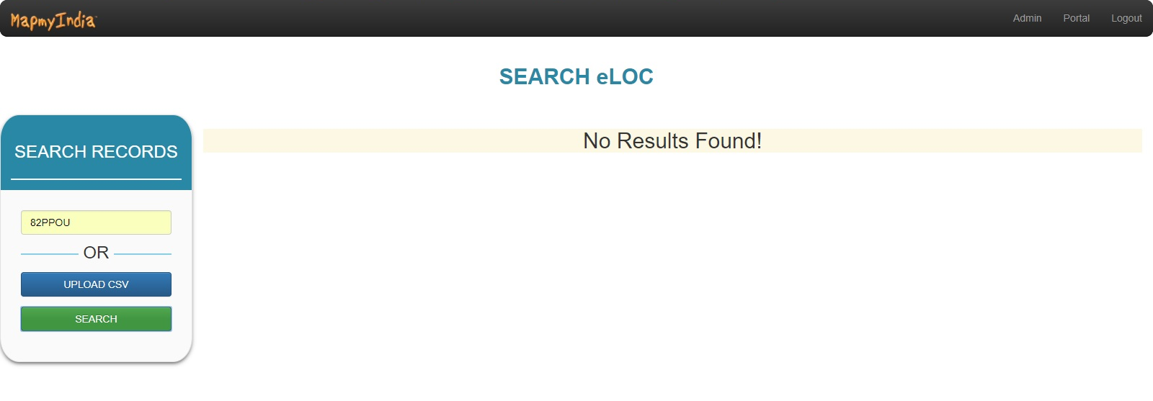

(For No Results Found)
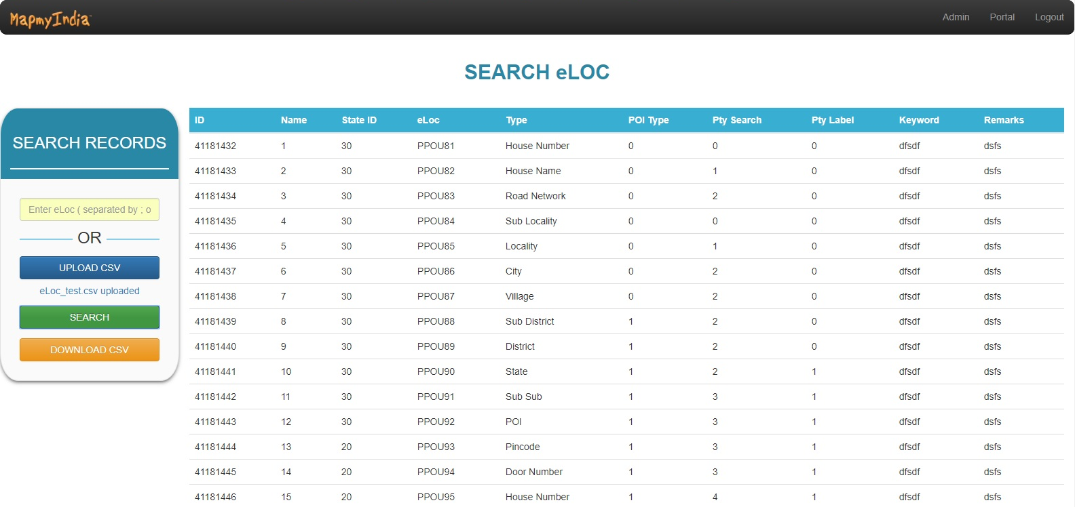

(For Results Found)

- Download CSV Button :- On successfully finding the results, a Download CSV button fades in. On clicking this button, the current records are downloaded to a CSV file.
